P3 Newsletter
Welcome back to Term Two!

This term we will be using Nessy to consolidate and improve our phonics knowledge. When reading books in class we will continue to sound out words. This will help with increasing fluency and our common word knowledge. For writing, we will explore Vocabulary, Connectives, Openers and Punctuation (VCOP) to expand our story writing skills.
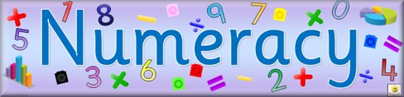
We will
- practise counting in 2s, 5s, 10s and will attempt to transfer this skill to larger numbers like 20, 25, 50, and 250.
- add and subtract ten from 2-digit numbers
- double and halve 2-digit numbers.
- explore time using phrases such as o’clock, half past quarter to and quarter past.
- consolidate our knowledge of 2d and 3D shapes and learn to describe their properties.

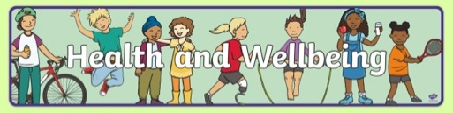
This term we will be exploring emotion words, behaviours, body sensations, triggers and regulation strategies. We will make links and discuss relationships, to help pupils become more emotionally literate. During PE sessions, we will continue to practice showing awareness of personal space, balance in various shapes and move with purpose.

We have two topics: Weather and Old and New Toys. We will explore materials and their properties as well as the changing of states of water. We will compare aspects of people’s daily lives in the past with our own.

Reminders:
- Please ensure you are connected to Seesaw and Google Classroom and get in touch if you require support with this.
- Children should not take items to school with them such as fluffy teddies and small toy items. This is to reduce the risk of Covid being transferred as well as help your child focus on their learning.

How to support your child’s learning at home:
- Each week activities will be uploaded to Google Classroom to practise for home learning.
- Have your child use Nessy at least three short sessions a week.
- Read stories with them and practice retelling the story together.
- Practice counting to 20 and back to 0 (don’t forget number 13!), count in 2s, 5s and 10s.

Please do not hesitate to get in touch if you have any questions or queries.

Miss Brown

