Relationships Policy
August 2020

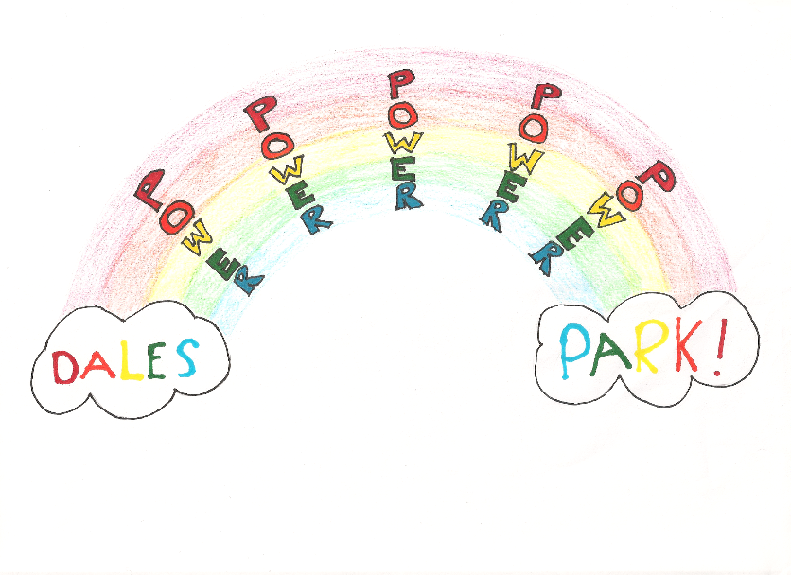

Overview
At Dales Park, we are committed to promoting positive relationships for ALL.
‘Botheredness needs to be a deliberate daily act that is built into the teaching routine. It is relationship building done properly, in slow motion. Gentle, kind and caring.’
Paul Dix, ‘When the adults change, everything changes.’

Our Vision
At Dales park, we are EMPOWERED to be engaged, respectful, outstanding, wonderful and feel proud.

Our Values
POWER
Proud- feeling really pleased with our achievements
Outstanding- exceptionally good
Wonderful- inspiring delight
Engaged- focussed on our learning
Respectful- showing admiration for others

Our Aims
We aim to be EMPOWERED and EMPOWER others daily.
I’ve got the power in me, You’ve got the power in you!

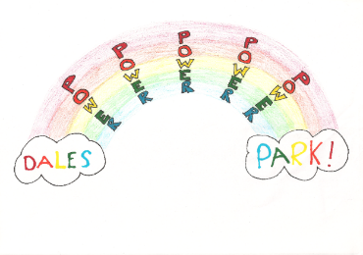

Our Approach
Consistency is key in promoting positive relationships.
- Consistent positive praise and reward systems
- Consistent use of positive language
- Consistent environment
- Consistent education of all in building positive relationships
- Consistent use of a zero-tolerance approach
There may be times that a minority of children need more support forming positive relationships other than using positive praise/ rewards and a zero-tolerance approach. In these cases, a meeting would be held between school, parents, and the child to decide on the best course of action and achievable targets. These interventions and targets would be implemented and monitored on a regular basis. The CONSISTENT factor in these instances and success for the child, is the collegiate working between parents and the school to get it right for the child.

System of rewards
- Weekly assemblies where certificates are awarded for exceptional work in class, improved work/ behaviour, or any outstanding achievements that week
- Classroom incentives such as beat the teacher, dojo points, table points, recognition boards, pebbles, stickers, earning class treats
- House points/ incentives
- House captain roles and responsibilities
- Roles and responsibilities throughout the school such as, Eco member, pupil council member and Rights Respecting Schools member

Health and Wellbeing
During the school year, all children will engage in whole class work, targeting the social and emotional aspect of Health and Wellbeing. This work will include-
- Understanding their emotions and the emotions of others
- Understanding how to manage and regulate their own emotions
- Develop a clear understanding that we are all special and unique
- Respect ourselves and respect others

Zero tolerance
At Dales park there is a zero-tolerance approach to any of the following behaviours-
- Deliberate hurting of others
- Use of bad language
- Spitting
- Deliberate destroying of furniture or objects
If a child were to display any of these behaviours, they would automatically receive a 15-minute detention at their next break. If this was on a Friday after lunch, then this detention would be in the afternoon during any reward time the class had achieved. This would not roll over until the Monday as we like to start the week positively.
The child parents/ carer would be notified of the detention through text/ email. The reason for the detention would be included in the text/ email. This would be then be recorded in the child’s chronology.

In some cases, staff may have to deal with violence . A coordinated, planned approach potentially provides staff with vital additional expertise, professional development and resources to meet the needs of the establishment’s community.
Aberdeenshire policies and procedures used to support staff when dealing with very challenging situations at Dales Park are:
- Risk Assessment Procedures
- Violence at Work Policy
- Violent Incident Reporting System
- Physical Intervention Policy
- Exclusion Guidelines- https://www.aberdeenshire.gov.uk/media/3901/policy_disc_exclusion.pdf
- Aberdeenshire Educational Psychology Service – http://www.aberdeenshire.gov.uk/schools/eps/about-the-educational-psychologyservice/

Restorative approaches
The key principles of restorative approaches are:
- Being responsible for one’s own actions and their impact on others
- Respecting other people, their views, and feelings
- Empathising with the feelings of others
- Being committed to equitable processes
- Willingness to create opportunities for reflective change in pupils and staff

The approach involves finding a solution to the problem. Instead of asking 'Who's to blame and how are we going to punish them?’
Focus is put on reasons, causes, responsibilities and feelings.
Those involved are asked questions such as 'Who has been affected and how?' and 'How can we put it right and learn from this experience?
The Restorative Questions:
- What happened?
- What were you feeling / thinking at the time?
- What do you think / feel about it now?
- Who has been affected by what has happened? In what way?
- What impact has this incident had on you and on others?
- What has been the hardest thing for you?
- What do you think needs to happen to make things right?
- What do we need to do make sure this doesn’t happen again?

The questions are neutral and non-judgemental, they are about the wrong-doer’s behaviour and its effect upon others, and they are open questions which require an answer. They take everyone from the past (what happened) to the future (repairing harm) and require people to reflect on who has been affected. They are likely to help the wrongdoer develop some empathy for those affected.

Anti- Bullying
Bullying in any form is intolerable and unacceptable.
Parents/carers, pupils and teachers have a responsibility to work in partnership to maintain a high standard of behaviour and an environment free from bullying behaviour. Aberdeenshire Council believes that everyone should be treated equally and with respect.
Bullying takes place when the actions of an individual or group of people cause harm to someone by taking advantage of an imbalance of power within a relationship (whether perceived or real). Bullying behaviour is abusive.
Bullying behaviour is often displayed as a result of past experiences which affect and impact on current actions.
Bullying can be verbal, physical, mental/emotional or cyber. It can be intentional or unintentional, direct or indirect, persistent, or a one-off incident. People who experience bullying behaviour feel vulnerable and/or socially isolated.
At Dales park we implement programmes of education about bullying from an early stage and revisit this topic at all stages of education.
We also have regular opportunities available for parents/carers to obtain information on our school systems and strategies relating to bullying and how to respond in a supportive and appropriate manner.
We encourage pupils to teach and share key messages about bullying with other pupils and with parents/carers including the short and long term impact of bullying.
At Dales Park we ensure that pupils, parents/carers and teachers are aware of support available beyond school (e.g. Childline, Samaritans, Police Scotland, Parentline).
We participate in planned Aberdeenshire Education and Children’s Services events in order to deliver key messages relating to bullying and to support ongoing curricular work.

