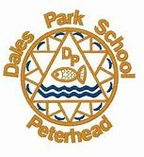
Dear parents/carers,
Hello and welcome to Term 2. This newsletter will tell you about what we will be doing in class this term, as well as containing some important class information.
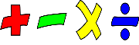
Maths
This Photo by Unknown Author is licensed under CC BY-SA
This term in maths we will be focussing on money, fractions and coordinates. We will also be practicing times tables and working on other areas of mental maths. Home learning ideas for these topics will be included in the weekly activities posted on Google Classroom.
Literacy
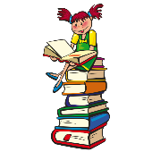
Pupils are now working in their reading groups and will be reading a variety of fiction and non-fiction texts. As well as reading aloud to develop fluency and expression, pupils will be using the skills learned last term to complete a range of activities with their books. Due to current circumstances, books will not be going home. Should you wish to do reading at home with your child I would suggest reading a variety of texts with them, such as newspapers and magazines as well as fiction.
Pupils will continue to work on their VCOP skills in our weekly taught writing lessons. These lessons will cover a variety of genre. VCOP is:
Vocabulary- the use of adjectives and descriptive phrases, and the use of more interesting words (e.g. ancient rather than old).
Connectives- joining sentences together using words such as but, so, because to vary sentence length.
Openers- thinking about how we start a sentence, using language such as next, after a while to create flow in our writing.
Punctuation- ensuring we are using basic punctuation such as capital letters and full stops correctly and exploring more advanced punctuation such as speech marks.
Context
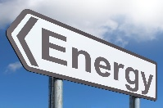
This term, our context will be ‘Energy’. This will involve investigating how energy is stored and transferred, and how wasted energy can be reduced. We will also be investigating non-renewable sources of energy such as oil and gas.
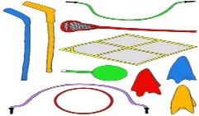
PE
This Photo by Unknown Author is licensed under CC BY-ND
PE will continue to take place on a Tuesday, and pupils should come to school appropriately dressed for a PE lesson on this day. Miss Kaur will be taking the class for PE, as well as working with them to cover other health and well-being outcomes.

Seesaw
We will continue to use Seesaw to share pupils’ learning.
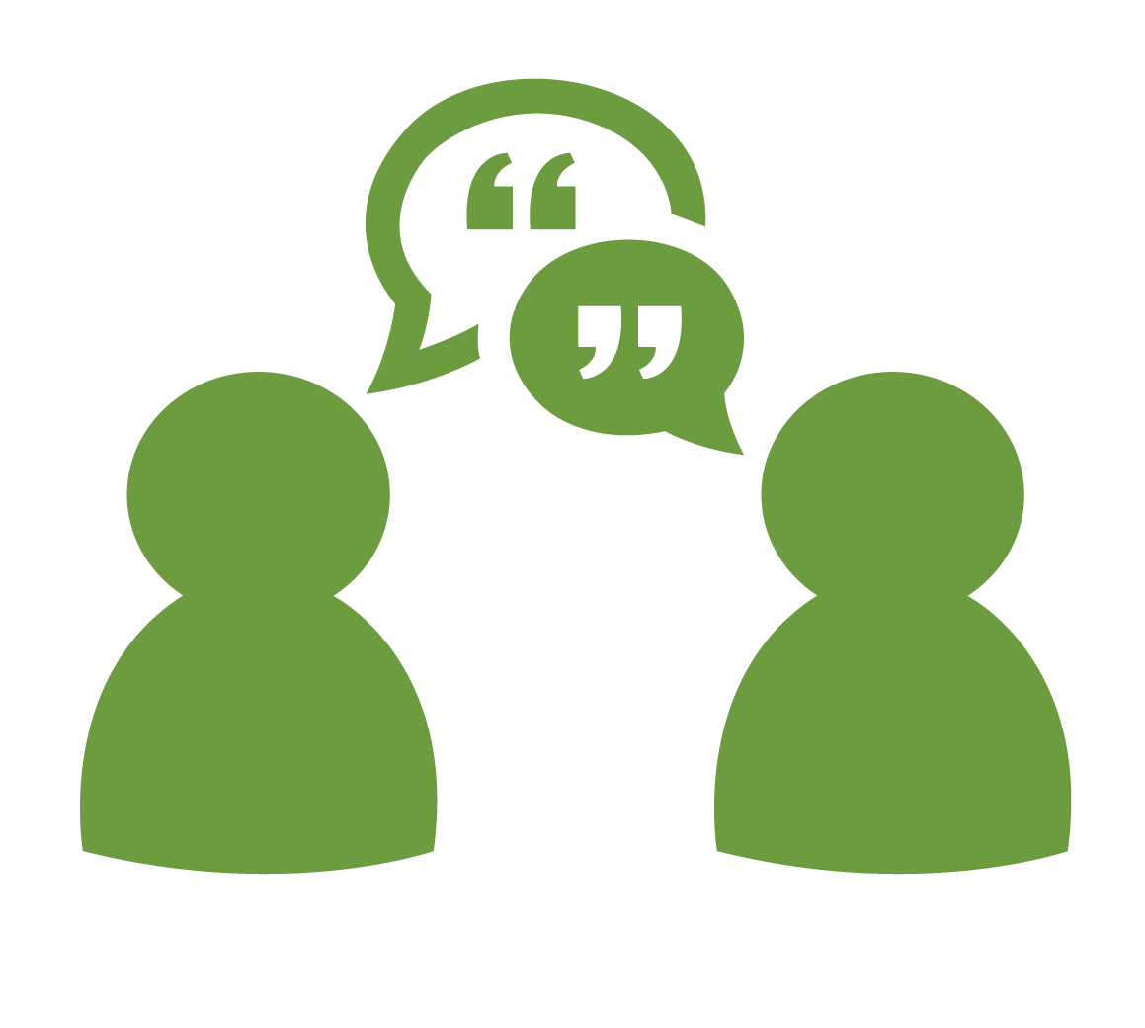
Google classroom
This Photo by Unknown Author is licensed under CC BY-SA-NC
Pupils should ensure that they have accepted the invitation to their new Google Classroom. This will be used to set the home learning tasks.
Please do not hesitate to contact me if you have any questions.
Mrs Telford

