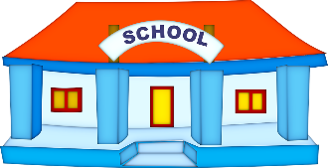
P6 Term 2 Newsletter
Mrs Bond / Mrs Davidson / Miss Kaur

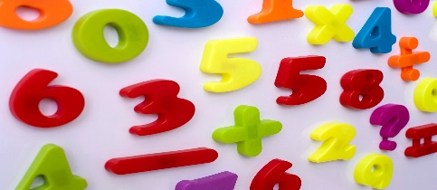
Numeracy – Mrs Bond – will be continuing to teach Whole Number, focusing on addition, subtraction and multiplication. Education City is available to use at home. If you need the login and password details for home then please ask your son/daughter to let us know or send us a message via SeeSaw.
This Photo by Unknown Author is licensed under CC BY
Maths – Mrs Davidson will be continuing to teach Data Handling with more of a focus on creating their own charts and diagrams, while explaining what the results of the charts are telling them.

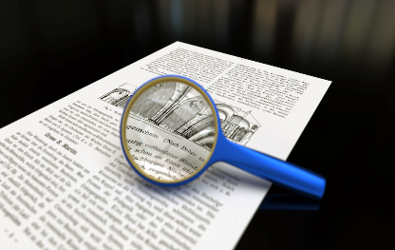
Literacy – Group reading will start back in class this term, however reading books will not be sent home. We will focus on grammar, punctuation and comprehension during these sessions. Spelling will now be done through an online programme called Nessy. This programme can be accessed from home and will feature as one of the weekly tasks for home learning. Details will be sent through Seesaw.
This Photo by Unknown Author is licensed under CC BY

PE – We will have PE with Miss Kaur on a Thurday morning. The children can come to school in their PE clothes on as changing is not allowed at this time. Please ensure your child has suitable footwear to take part.
In term two, we will be focusing on basketball. The pupils will be learning a range of different passes and engage in activities to improve their ball control. Pupils will be introduced to offence and defence positions and learn how to play the positions most suited to them. They will be taught the rules and apply what they have learnt to the game.
Mrs Bond - This term the children will be continuing to discover key features and landmarks from around Scotland, enhancing our mapping skills and sense of place within the world.
This Photo by Unknown Author is licensed under CC BY-SA

Mrs Davidson- last term, we researched famous people/events and made notes on these. This term, we are going to turn these notes into a report, then order these in the date they happened. The pupils will choose how they want to share their reports with the others in the class/school; they can read it out or make a video to show others. The culmination of this topic will be to discuss the importance of these people/events and their impact of society.
This Photo by Unknown Author is licensed under CC BY

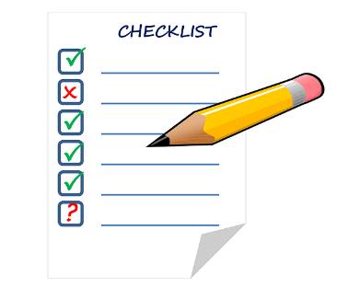
General information reminder – The children do not need to bring a bag to school with them as we have all the equipment they need in school. If the children bring a pencil case to school, it must remain in their school bag. It is important that the children DO NOT take any personal items or toys/trinkets into school. There has been an increasing number of items being taken from home. This is NOT allowed as per the Aberdeenshire risk assessment for Covid Protection and Control.

Water fountains can only be used to fill up water bottles. Please unsure that the children bring a water bottle with them which they can refill throughout the day.
Home learning suggestions will be provided through Google Classrooms, this will be available from the week beginning the 9th of November. This will be uploaded weekly, on a Monday. Details of how to access Google Classrooms will be sent via Seesaw.
We are available via SeeSaw on weekdays from approximately 8am until 4pm. This is the best way to get in contact with us. If you haven’t managed to connect to SeeSaw yet, then please ask your child to let us know so we help you.

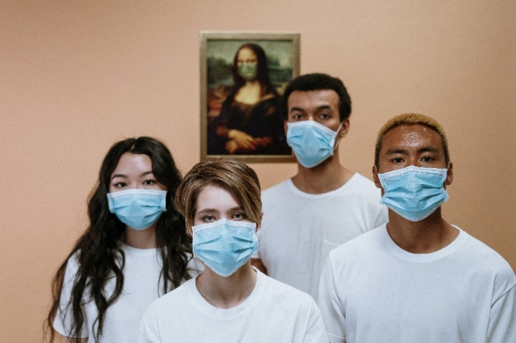

STAY SAFE

